**WeatherPy Analysis**

**Observation 1 -** The City Latitude vs. Max Temperature plot of over 500 randomly chosen cities shows that latitude between -20 to 20 are the hottest regions on the planet, and temperature drops when moving further away from the equator.

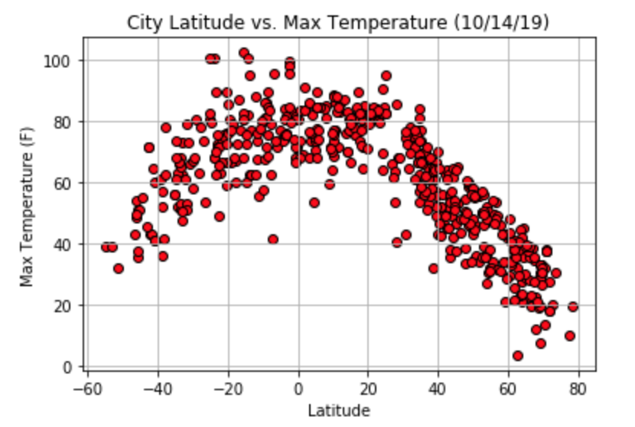

**Observation 2 –** Both humidity and cloudiness do not show a strong relation with latitude based on the City Latitude vs. Humidity plot and the City Latitude vs. Cloudiness plot. However, since the coordinates were chosen uniformly at random, these plots should be somewhat accurate on presenting the distribution and density of cities. It is pretty obvious that the Northern Hemisphere has more cities.

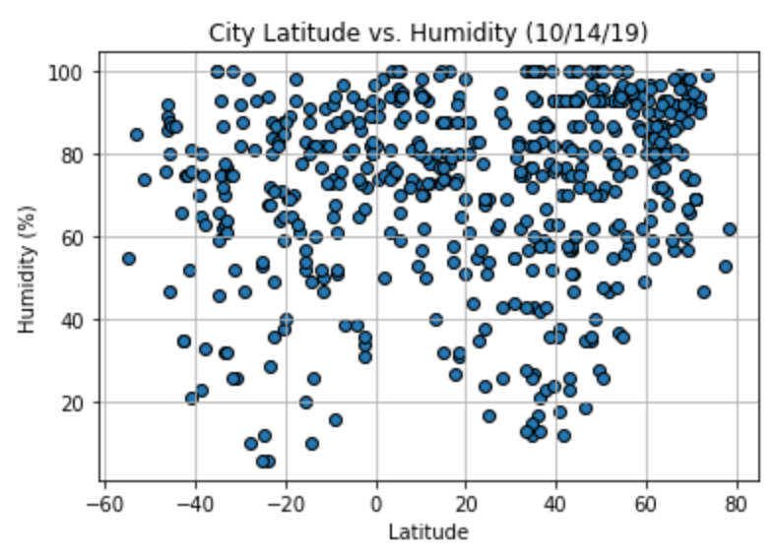

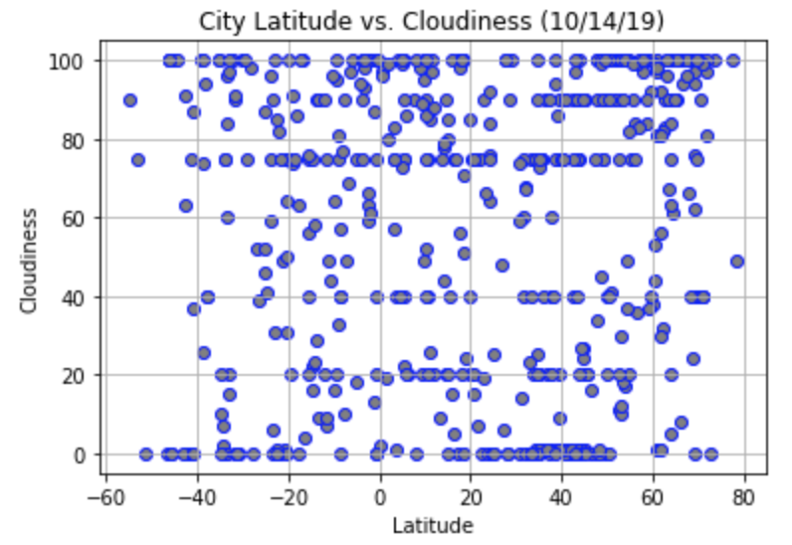

**Observation 3 –** From the City Latitude vs. Wind Speed plot we can tell that chances of getting extremely strong wind around the equator are slightly smaller. Yearly data will be needed to prove that.

